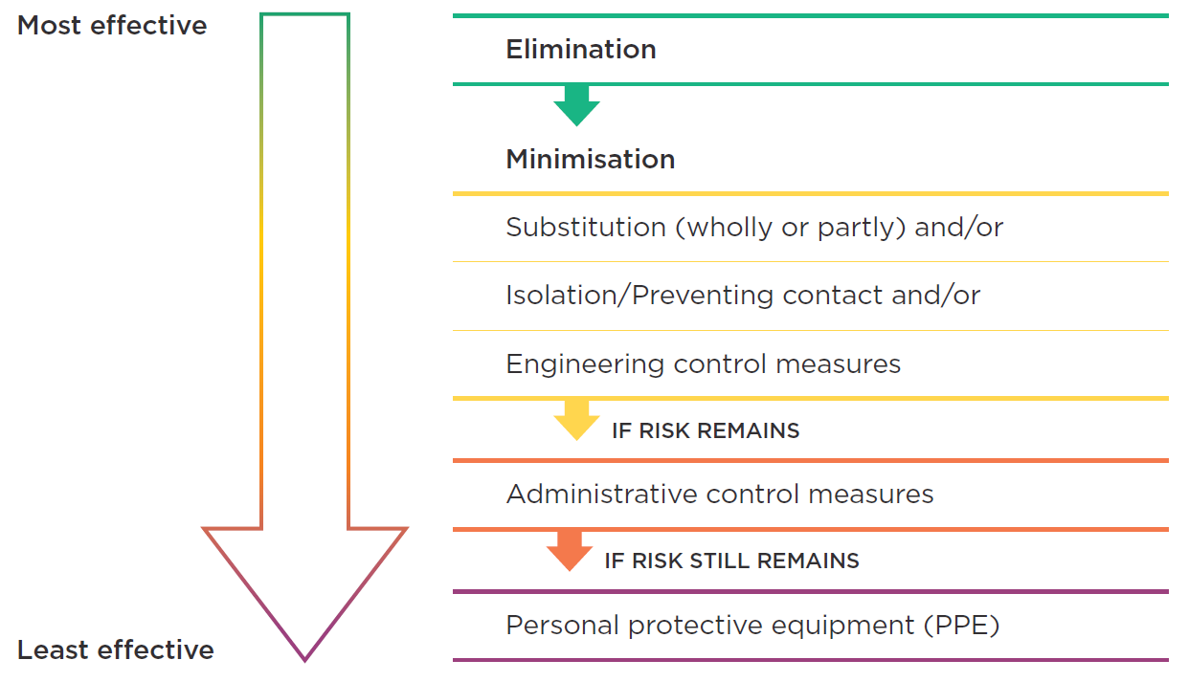
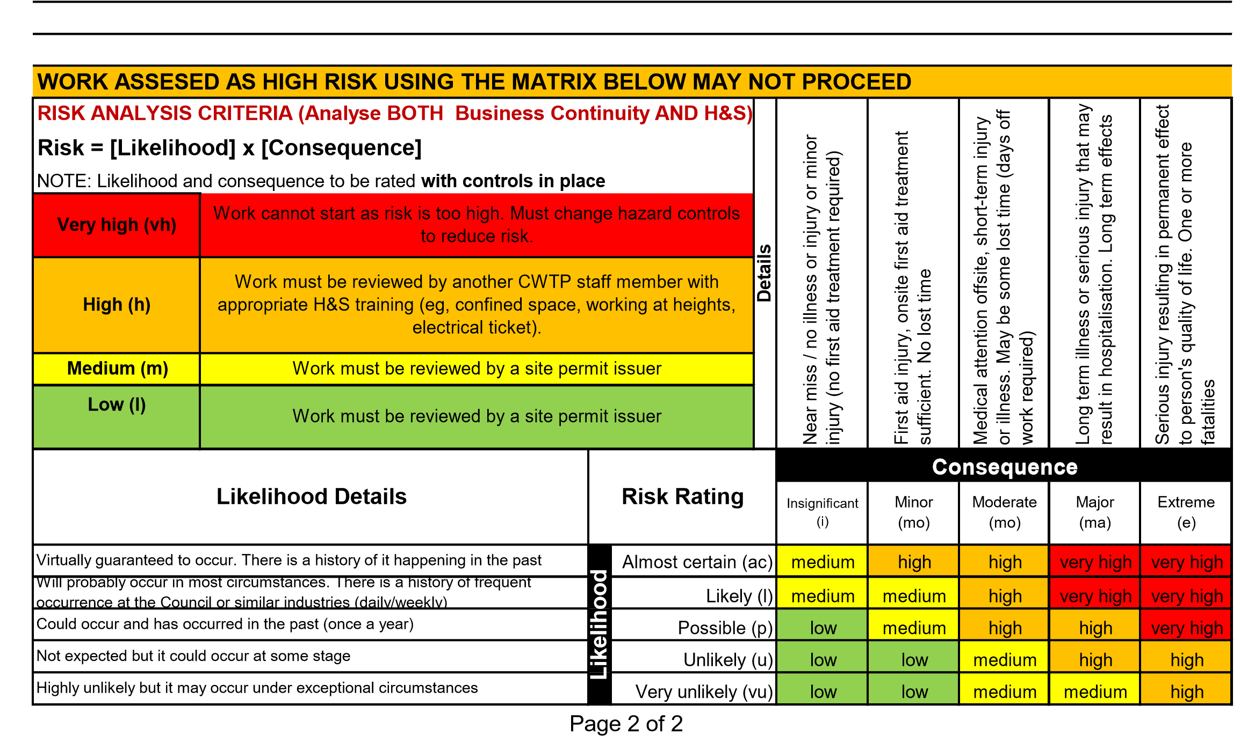
Minor
(mi)

Attach additional sheets as required, alternatively attach an existing Job Safety Analysis to this form |  |  |  | Risk Analysis (with controls)
Job Step |  | Significant Hazards (e.g. harm to people, damage to equipment, process disruptions, environmental damage, etc.) | Proposed hazard controls
 |  |  | Control Method (where no additional control is proposed, write "risk Accepted") | Likelihood | Consequence | Rating
Start-up – Hand over from operations to work activity
2
3
4
5
6
7
8
Close out – hand back from work activity to operations

