B-051

APPLICATION CHECKSHEET

Solid/Liquid Fuel Heating Appliance (Residential Only)

Address:

This checksheet shows you the minimum information that has to be supplied for a Solid/Liquid Fuel Heating Appliance (residential only) with your building consent application. Please complete each box in the Customer use column as you attach the information. Complete all sections using either a or Y where the information is provided, or a X or N/A where the information is not applicable to the building work proposed as shown on the key at the bottom of each page.

Customer use | 1. GENERAL  COMPLETE FOR ALL APPLICATIONS
a. Building Consent Application form to be completed online at Online Services (only use B-002 form for hardcopy or amendment applications)
- Completed and signed by the owner or by an agent on behalf of the owner.
b. Proof of Ownership:
Attached one of the following:
- Certificate of Title
- Lease
- Agreement for sale and purchase
- Other document showing full name of legal owner(s) of the building
c. Relationship to owner:
You as agent must state the details of the authorisation from the owner to make application on the owner’s behalf (e.g. contractual agreement etc). Please note: This question must be answered before your application for consent can be processed.
d. Application Fee:
Fees payable are set out in the Building Consents Fee Schedule available on our website and will be invoiced on acceptance of the application
2. THE PROJECT
COMPLETE FOR ALL APPLICATIONS
a. Details of the appliance:
- Make and model
- Authorisation No
- Confirm if new or second-hand appliance
- New wetback connection:
  - confirm that an anti-scalding device will be fitted. This requirement does not apply if an existing hot water booster or wetback is being replaced, or is existing elsewhere in the hot water system. The hot water cylinder must be open vented.
- Replacing an existing operational solid fuel burning appliance:
  - confirm the age of the existing solid fuel burning appliance (to the nearest year), and provide Building Consent number (if known) for the installation of the operational solid fuel burning appliance.
- Not replacing an existing operational solid fuel burning appliance:
  - provide the resource consent number from Environment Canterbury (ECan) (applies to wood, wood pellet or coal burning appliances only)
- Estimated value of appliance and installation (incl. GST)
b. Manufacturer’s installation specifications/instructions (1 copy)
For the correct installation and use of the heating appliance. The specification/instructions must relate to the specific make and model of the heating appliance to be installed.
c. Flue and Flashing details
- Flue Height: The minimum flue heights specified in AS/NZS 2918:2001 (Solid Fuel/Liquid Fuel Heaters) or the manufacturer’s installation instruction may be insufficient if combustion problems and smoke or odour nuisance are to be avoided. Consideration should be given to extending the flue height above those required by the manufacturer or AS/NZS 2918:2001.
Note: If the flue height exceeds 1.2m above the roofline, consideration needs to be given to NZ Building Code performance B1.3.3.
The flue will need lateral bracing to withstand wind-load. If applicable please include details of complying bracing.

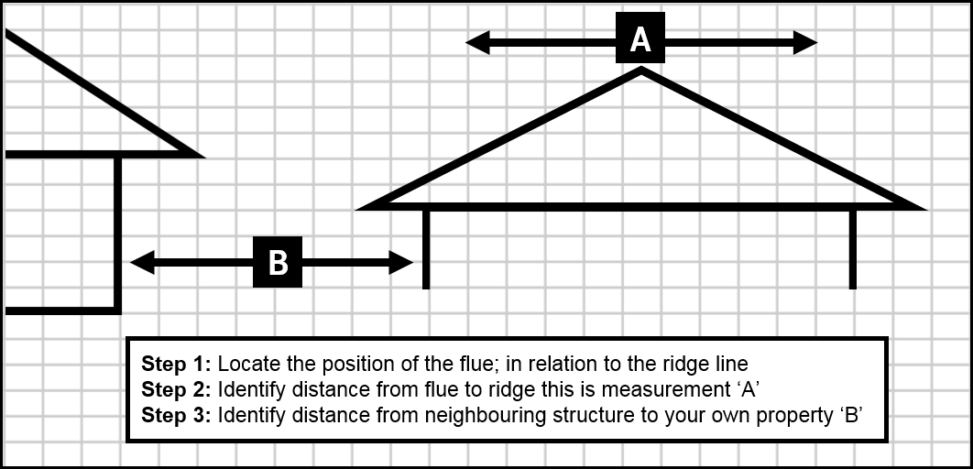
d. Draw a Full Scaled Floor Plan (All Floors) Showing: (1:100)
- Location of the heater (existing location also if different from proposed).
- Location of all walls, windows and doors, with all rooms named (for all floors).
- Location of existing/proposed smoke alarms (that comply with the relevant standards including having a “hush” facility); they must be marked with on the floor plan (refer to B-311 for guidance on smoke alarms locations). Smoke alarms will be inspected and tested prior to the issue of the code compliance certificate. Note: If the property has a sleep-out, the sleep-out is also required to have smoke alarms fitted.
- Location of the existing water cylinder if a wetback/hot water booster is to be fitted.
- Insert or inbuilt installation: Third party statement/report on condition of chimney
Please provide verification of the structural integrity of the existing fireplace/chimney where the installation involves an insert or inbuilt type appliance. Verification includes a report from a suitably qualified or competent person and could including photos, etc.
For earthquake damaged chimney repairs: Refer to Ministry of Building Innovation and Employment (MBIE) guidance document on repairing and rebuilding houses affected by the Canterbury earthquakes - www.building.govt.nz/building-code-compliance/canterbury-rebuild/ Appendix A3 page A3.1
- Provide cross section details where applicable:
  - Cross section through building showing flue penetration through floor joists/fire protection (only required if the flue penetrates through an intermediate floor and the building is two or more stories in height.
  - Cross section through building showing roof material and flashing details of the flue (only required if flue penetration is new).
- Second hand solid/liquid fuel burners cannot be installed unless:
  - A current clean air approval label is attached to the appliance (not applicable to some minor rural areas of Christchurch).
  - Written evidence is provided to show that the appliance meets Building Code requirements. (An acceptable method is a satisfactory report from the manufacturer or manufacturer’s agent.)
  - A new inner flue is required in all cases.
- Liquid fuel storage: Show type of fuel (e.g. diesel, home blend, kerosene), size and location of the fuel storage tank in relation to the building and site boundaries. Wall openings (windows or doors) and wall cladding material within one metre of the storage tank should be shown (including neighbouring properties).
- Certification that the storage tank compiles with AS1692.

NOTES: Second Hand Solid/Liquid Fuel Burners cannot be installed unless:
- A current Clean Air approval label is attached to the appliance (not applicable to some minor rural areas of Christchurch).
- Written evidence is provided to show that the appliance meets Building Code requirements. (An acceptable method is a satisfactory report from the manufacturer or manufacturer’s agent.)
- A new inner flue is required in all cases.
- The issue of a building consent does not relieve the owner of any duty or responsibility under any other Act.

